BerettaFest 2025 Proposal - Watkins Glen, NY

Welcome to Watkins Glen, New York where you can visit the State Park with its beautiful waterfalls, taste some delicious local wines, soak up some aviation and motor racing history AND drive the racetrack!
https://www.explorewatkinsglen.com/free-travel-guide/#

My personal belief: It is not the city or the itinerary that makes a BerrettaFest successful. There have been years without a racetrack, and others when racing was rained out. A successful BerettaFest is the gathering of a fabulous group of people that we all call family. Just show up and I promise that it’s all good from there!

For those of you who have never attended, come join the fun! You do not need to have a Beretta to attend the event! Come and meet this fantastic group and see some amazing cars – I promise that you’ll want to return year after year…

There are those that have done (what I call the hero’s drive) 1500 miles… Just ask them, they will tell you it was absolutely worth it... and I include myself!

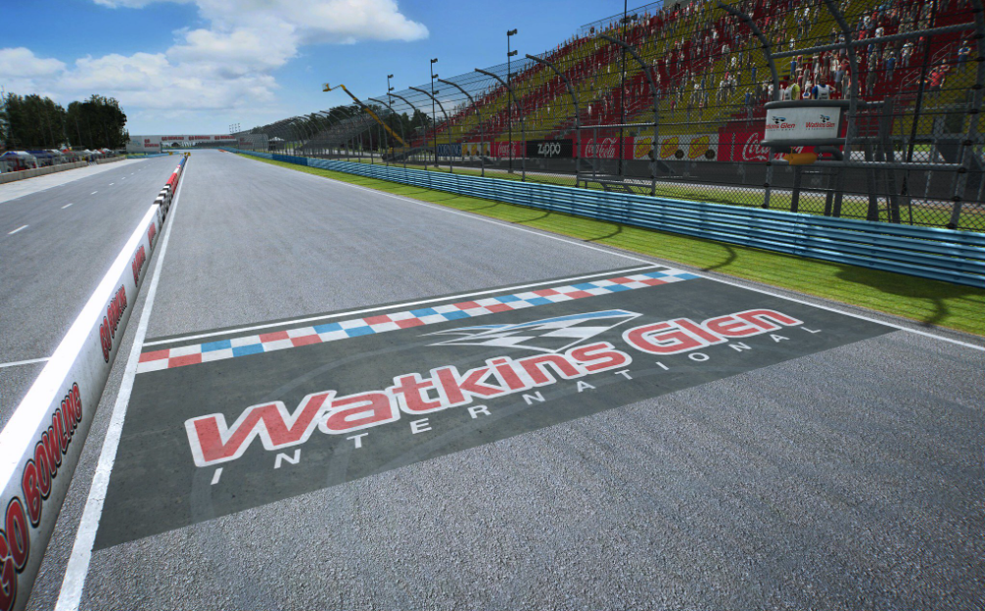

BerettaFest 2025 Watkins Glen, NY Proposed Itinerary:

Wednesday: Early hotel check-in
6 PM?? Annual BerettaFest Taco night!
Typically in the hotel breakfast or conference room, occasionally in the parking lot. The King and Queen of taco night will prepare a scrumptious spread of all the fixin’s for you to make a traditional BerettaFest taco. An event not to be missed!

Thursday:

8:00 AM – Noon: Check-in/Registration
12:00 PM-5:00 PM: “Drive the Glen”; Watkins Glen est. 1956. Drive your car on the 3.45 mile race track ($30 per car fee)
Track is open from noon until 5pm
https://www.theglen.com/drive-the-glen-5/
2790 country route 16, Watkins Glen, NY 14891

5 PM-???:
Depart the Glen and cruise to our supper at Nickels Pit BBQ. Enjoy indoor or outdoor dining in the city of Watkins Glen. https://www.nickelspitbbq.com/menu-watkinsglen

Back to the hotel for our traditional parking lot gathering till the sun comes up …

Friday:

9:00 AM to 5:00 PM Free time to explore on your own or in groups
Choose to explore one, or more, of the following options:
- Glenn H Curtiss Aviation Museum – (20 miles/27 minutes) (open 9:00 AM to 5 PM) ($18.92) https://glennhcurtissmuseum.org/
- International Motor Racing Research Center at Watkins Glen (open 9:00 AM to 5:00 PM) https://www.racingarchives.org/
- Nature walk at Watkins Glen state Park https://parks.ny.gov/parks/watkinsglen/maps.aspx
- Castle Grisch Winery https://castelgrisch.com/ (open 11:00 AM to 8:00 PM Thursday through Saturday)

Evening:
5:00 PM – 10 PM Empire Dragway, 2011 New Road, Leicester, NY 11481 (75 miles) https://www.empiredragway.com/
- 5 PM Depart hotel and cruise to Empire Dragway
- 6 PM-10 PM: Test and Tune ($40)
- 10 PM return to hotel Empire Dragway, 2011 New Road, Leicester, NY 14481 (75 miles)
OR
- 4 PM – 8:30 PM Past to Present Cruise Night in Horseheads, NY (25 min drive) (17 miles) https://carsandcoffeeevents.com/event/friday-night-past-to-present-cruise-night/2024-08-23/?srsltid=AfmBOoqpsMeoZxGqvYN-PCves504oJHjRvAjdBUQref5Vhl2LLdlVnNi
- Group dinner at Louie’s Hanover Square restaurant https://www.louieshanoversquare.com/
Back to the hotel for our traditional parking lot gathering till the sun comes up…

Saturday

Morning: Wash and shine those cars…

Afternoon:
- 12 PM – 4 PM: Picnic at Watkins Glen State Park https://parks.ny.gov/parks/watkinsglen/maps.asp
1009 N Franklin St
Watkins Glen, NY 14891
*New York State charges $10.00 per car to enter their state parks. The pass is good for the whole day, which includes the use of their trails*
- 4 PM depart for group photo pics.
- Return to hotel and chill out…it’s been a busy, long and HOT day… Group restaurant dinner, or order in pizza and subs to the parking lot

Sunday
Well, it’s the day we say goodbye until next year… safe travels everyone… it was great seeing old friends and meeting new ones. Thanks for coming to Watkins Glen!

